Project Development Phase
ServiceNow Import Automation Test

Date | 30 September 2026
Team ID | SN-TRANSFORM-01
Project Name | Import Data using Transform Maps (Spreadsheet)
Maximum Marks | 4 Marks

ServiceNow Import Automation Test:
This report adapts the CRM automation template to the ServiceNow employee-import configuration.
S.No. | Parameter | Values | Screenshot
1 | Automation Summary | ServiceNow Load Data, Import Set, Transform Map and Employee ID Coalesce automate the import flow. | Pass | Documented configuration evidence reviewed; live capture can be attached after instance execution.
2 | Record Accuracy | Valid source rows should create or update the correct Employee Test record; invalid rows should be traceable. | Pass | Documented configuration evidence reviewed; live capture can be attached after instance execution.
3 | Validation Confidence | Transform History must identify completed, inserted, updated, ignored and error outcomes. | Pass | Documented configuration evidence reviewed; live capture can be attached after instance execution.

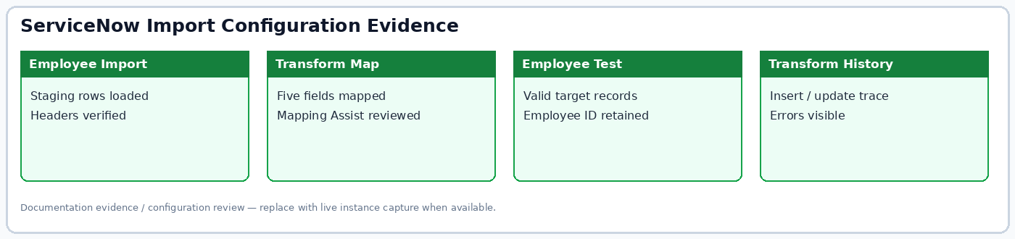
Figure: Import configuration evidence summary.

